Jobs to Be Done (JTBD)
Jobs to be Done (JTBD) is a product strategy framework that helps product teams understand customers (their struggles, context, and desired outcomes) and the market landscape.
It's a mental model that helps you understand the problem-space of the product that you are building.
The Bitcoin space is a very technical area that naturally leads builders to dive straight into solutions. JTBD is a useful method for Bitcoiners since it forces them to see things from the customers perspective. We want to understand the core motivations that resulted in someone using our product, JTBD helps us to do this.


Why?
We use JTBD to:
- Understand our customers, struggles and hopes to make progress in their lives, and the reason why current customers “hired” our product in the first place.
- Analyse our competitors through the lens of JTBD thinking.
- Understand what triggers our customers' behaviours, why they are frustrated or delighted with our product.

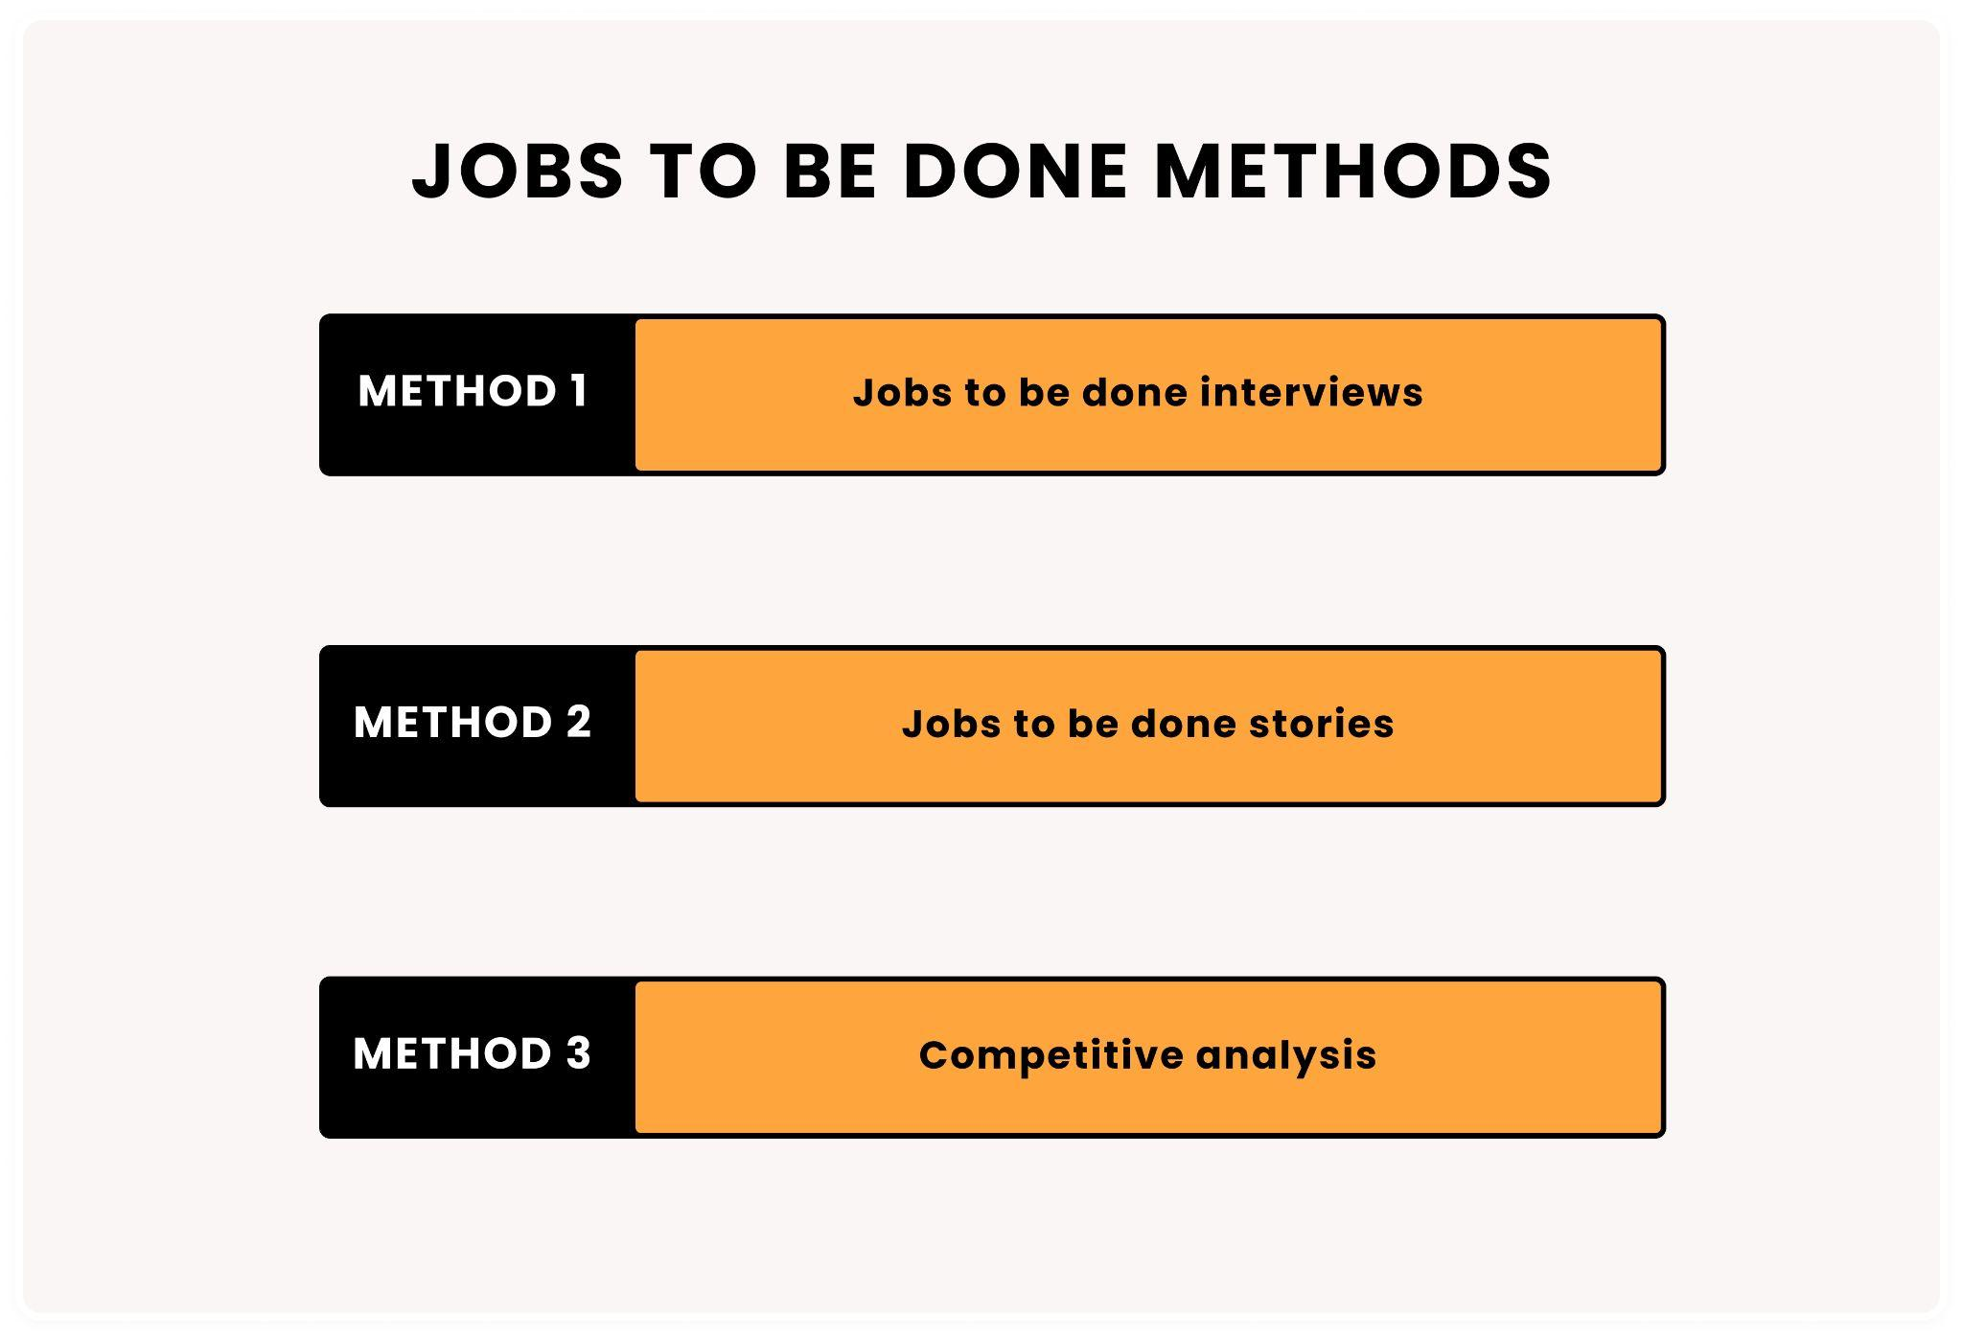

What is a “job”?
The overall theory is that people start to use an application, business, organization to get a “job” done. The job can be loosely defined as the task that the person expects the app to do. That task can be one singular main task or it could be a series of tasks.

How to run JTBD?
There are two steps in this process:

Step 1: JTBD interviews
Open the resources below which include an interview transcript and additional file to capture insights
Link to interview transcript
Link to summarising insights
Schedule customer interviews with your potential users or current users. In the interview try to help interviewees articulate the story of how they purchased your product.
Analyse the journey to purchase using a timeline and 4 forces
Your goal is to identify all the events that led to the purchase and describe the mental struggle that a customer experiences.
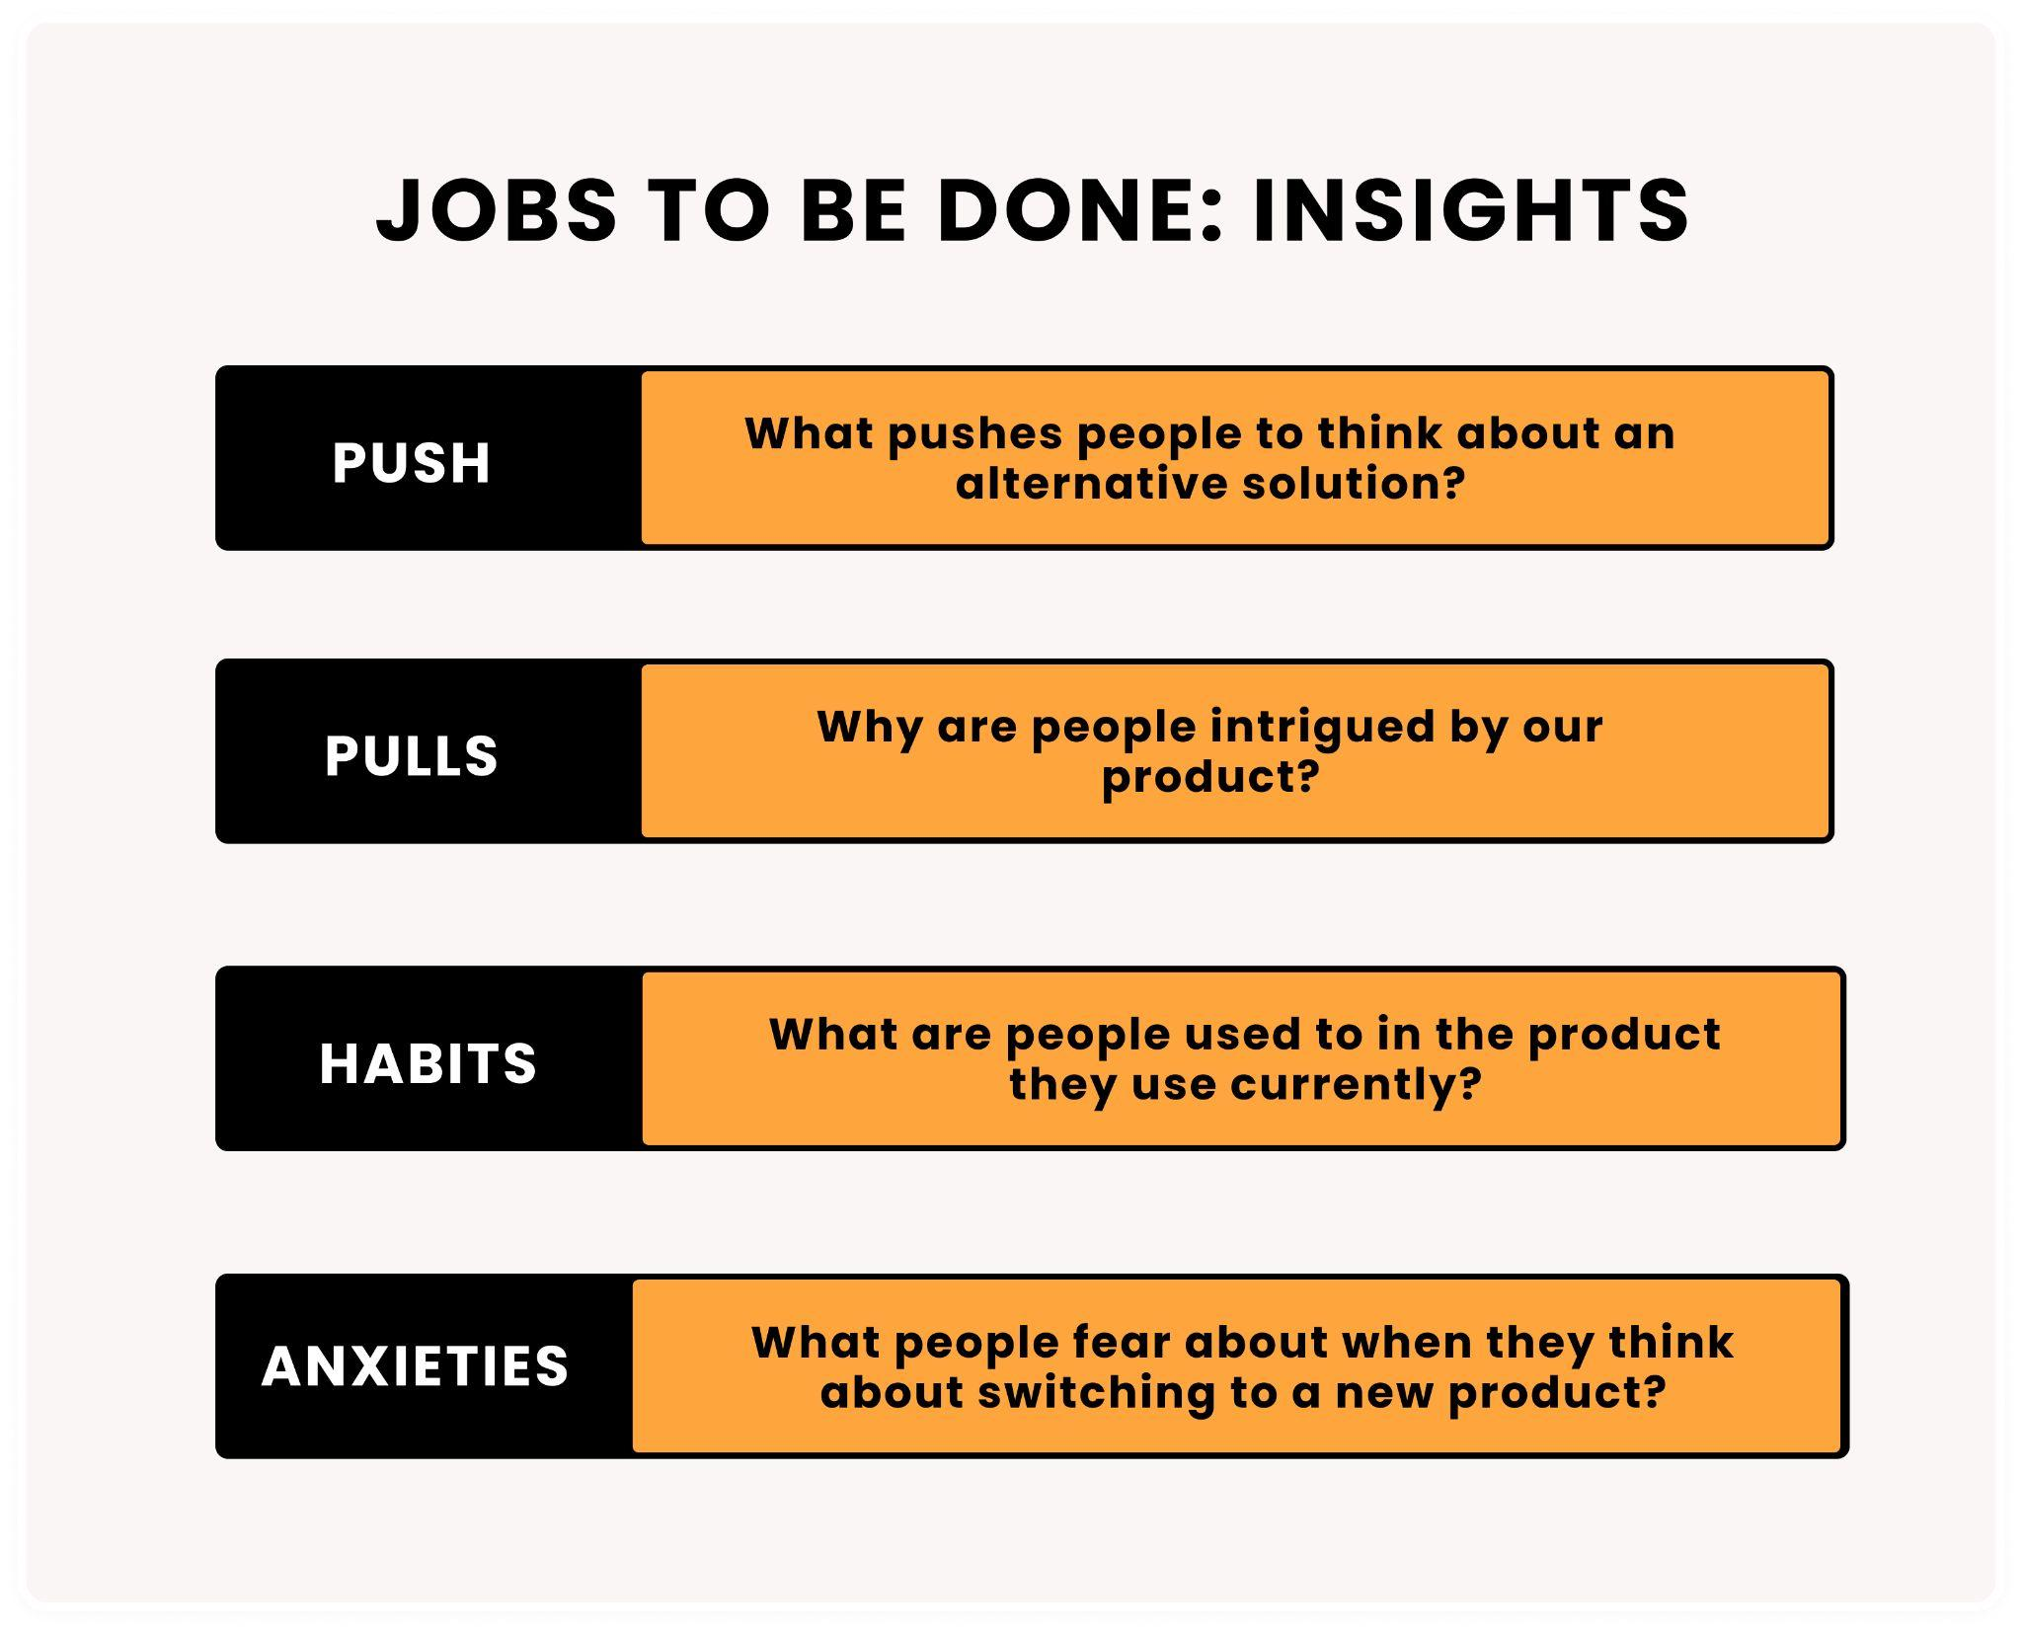

Analyse how the customer is using the product and what triggers consumption of specific features.

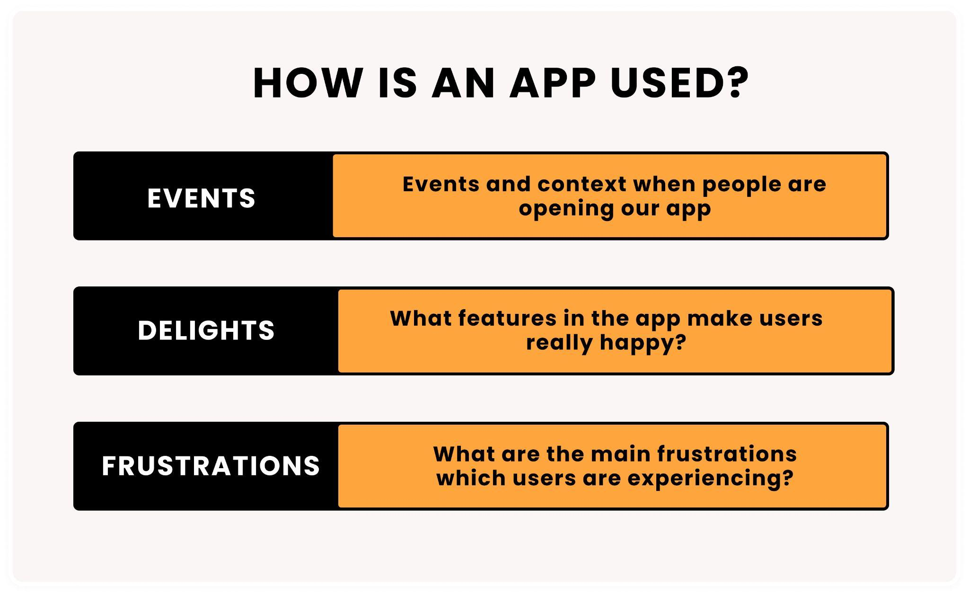
Repeat interviews and start looking for patterns. JTBD interviews are a form of qualitative research, so when you find patterns, you need to validate them with quantitative research like analytics, surveys.
Please note: in a JTBD interview, you’re not interested in people’s opinions. You’re interested in their real stories. Always try to redirect people to describe specific events and the context.
- Repeat interviews and start looking for patterns. JTBD interviews are a form of qualitative research, so when you find patterns, you need to validate them with quantitative research like analytics, surveys.
- Please note: in a JTBD interview, you’re not interested in people’s opinions. You’re interested in their real stories. Always try to redirect people to describe specific events and the context.

